Use Case Specification

DMT/RM01/TMP

|  |  |
| --- | --- |
| Project Code | PRJ_HotelManagement_001 |
| Project Name | Hotel Management |

|  |  |  |
| --- | --- | --- |
| Prepared/Modified by | Role | Date of Preparation |
| Harshita Ahuja | Test Engineer | 16/10/2018 |
| Reviewed by | Role | Date of Review |
| Himanshu,Ijas,Kartik | SME |  |
| Approved by | Role | Date of Approval |
| Christy | Test Manager |  |
| Circulation List |  | Version Number of the template: |
| Version Number | 1 |  |

<<Customer>> REVIEW HISTORY

<<Customer comments on the Use case along with the signed off is tracked here>>

|  |  |  |  |  |  |  |
| --- | --- | --- | --- | --- | --- | --- |
| Version | <<Version number>> |  |  |  |  |  |
| Date | <<Date of Review>> |  |  |  |  |  |
| Reviewed by | << Reviewer Name>> |  |  |  |  |  |
| Reviewed UI Specification doc | << Whether UI Specification doc is reviewed >> |  |  |  |  |  |
| All Open Queries/issues closed | << Whether all the open queries and issues resolved>> |  |  |  |  |  |
| Agreement on Assumptions | <<Whether all the assumptions have been agreed upon by the customer>> |  |  |  |  |  |
| Sign Off | <<Signature>> |  |  |  |  |  |

Disclaimer:

The scope of the project ‘<<Project Name>>’ is restricted to the contents of this signed off use case.

**TABLE OF CONTENTS**

1. Use case Name 4
2. Actor(s) 4
3. Preconditions 4
4. Flow of events 4
   1. Basic Flow 4
5. Exception Flow
   1. Exception Flow 1 5
   2. Exception Flow 2 5
   3. Exception Flow 3 5
   4. Exception Flow 4 5
   5. Exception Flow 5 6
6. Post Conditions 6
7. Special Requirements
   1. Performance 6
   2. Availability 6
   3. Business Rules 7
8. Diagrams
   1. Use Case Diagram
      1. For Successful Login 8
9. Scenarios
   1. Success Scenarios 9
   2. Failure Scenarios 9
10. Issues 9
11. UI Specifications 10
12. Assumptions 10
13. Revision History of the work product 10
14. Use Case Name: Hotel management system

Use Case ID: hotelmanagement1.0

**Brief Description:** This usecase describes the login system for hotel management system for

admin,employee and customers.

1. Actor(s)

1. Employee

2. Admin.

3. Customer.

1. Preconditions.

1.The actors should successfully sign up the site http://ndafile:8081/Spring_Hotel/signup.html.

1. Flow of Events

4.1 Basic Flow

**Name:** Succesful login into the system.

1. User enters username.
2. User enters password.
3. User selects role.
4. User Clicks on login button.
5. System will redirect the user to home page.

4.2 Exception Flow

Exception Flow 1: unsuccessful login due to invalid username or password.

1. User enters username.
2. User enters password.
3. User selects role.
4. User Clicks on login button.
5. System displays the error message “Please enter valid username or password”.

Exception Flow 2: unsuccessful login due to wrong selection of role.

1. User enters username.
2. User enters password.
3. User selects role.
4. User Clicks on login button.
5. System displays the error message “You are not signed up for this role. Please selects your role correctly.”.

Exception Flow 3: Web Server Down

1. User enters username.
2. User enters password.
3. User selects role.
4. User Clicks on login button.
5. The system displays an error message regarding web server unavailability problem

Exception Flow 4: Database Connectivity Error

1. User enters username.
2. User enters password.
3. User selects role.
4. User Clicks on login button.
5. The system displays an error message regarding database connectivity problem.

Exception Flow 5: Network Connectivity Error

1. User enters username.
2. User enters password.
3. User selects role.
4. User Clicks on login button.
5. The system displays an error message regarding network connectivity problem.

| Flow Name | Post Condition |
| --- | --- |
| Successful Login | System will redirect the user to home page. |
| Unsuccessful Login due to invalid username or password. | System displays the error message “Please enter valid username or password”. |
| Unsuccessful Login due to wrong selection of role. | System displays the error message “You are not signed up for this role. Please selects your role correctly.”. |
| Web Server Down | The system should display an error message to the user regarding web server unavailability problem |
| Database Connectivity Error | The system should display an error message to the user regarding the database connectivity problem |
| Network Connectivity Error | The system should display an error message to the user regarding the network connectivity problem |

1. Post Conditions

1. Special Requirements

6.1 Performance

The applicant will successfully login into the system as per their role.

* 1. Availability

1. Application is up and running 24*7.

1. Business Rules

| Business Rule Name | Business Rule Description | System action (if BR fails) |
| --- | --- | --- |
| BR01 | Username and password should be correct. | Error message is displayed if they are incorrect. |
| BR02 | Only 3 options are available for role. | Error message is displayed if not selected |

1. Diagrams

Use Case Diagram

* 1. For Successful Login

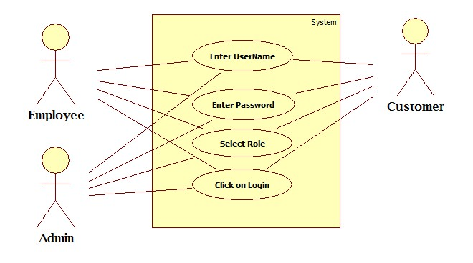

1. Scenarios

Success Scenarios

* Successful login of the user.

Failure Scenarios

* Login failed due to invalid username and password..
* Login failed due to invalid selection of the role.
* Login failed due to web server down..
* Login failed due to database connectivity.
* Login failed due to network connectivity.

1. Issues
2. What is to be done if web server is down?
3. What is to be done if there is data connectivity error?
4. What is to be done if there is network connectivity error?
5. UI Specifications

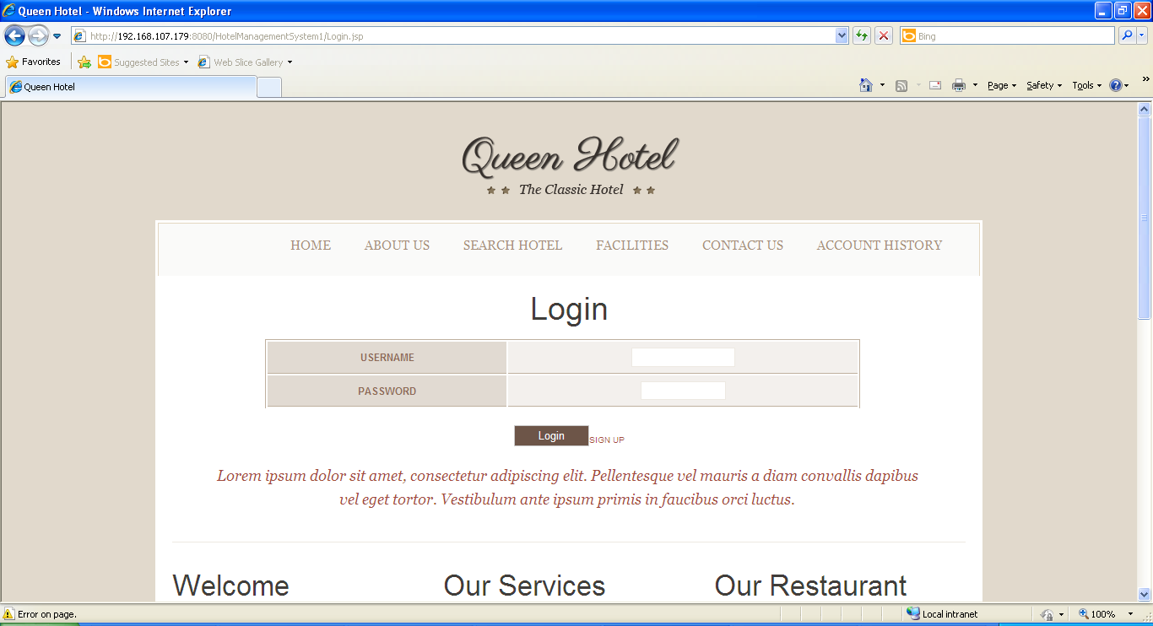

1. Assumptions

Only signed up users can login into the hotel management website.

1. revision history of the work project

<to be maintained by projects>

|  |  |  |  |  |  |
| --- | --- | --- | --- | --- | --- |
| # | Date | Version # | Section Changed | Details of changes made | Approved By |
| 1 |  |  |  |  |  |
| 2 |  |  |  |  |  |